SpringBoot

# Auditing in SpringBoot (spring data envers)

3. Annotate entity classes with

@Audited  
@EntityListeners(AuditingEntityListener.**class**)

@Data  
@NoArgsConstructor  
@AllArgsConstructor  
@Builder  
@Entity  
@Table(name = **"employee"**)  
@Accessors(chain = **true**)  
@Audited  
@EntityListeners(AuditingEntityListener.**class**)  
**public class** Employee **extends** BaseEntity{  
 @Id  
 @GeneratedValue(strategy = GenerationType.***IDENTITY***)  
 **private** Long **id**;  
   
 @Column   
 **private** String **name**;  
  
 @Column   
 **private** Double **salary**;  
  
 @Column   
 **private** String **city**;  
  
 @OneToOne(fetch = FetchType.***LAZY***,cascade = CascadeType.***ALL***)   
 **private** Account **account**;  
  
 @OneToMany(fetch = FetchType.***LAZY***, cascade = CascadeType.***ALL***, orphanRemoval = **true**)  
 @JoinColumn(name = **"employee_id"**)  
 @NotAudited  
 **private** List<Document> **documentList**;  
  
}

Here

@Audited - When you annotate a JPA entity class with **@Audited**, Hibernate Envers will automatically track changes to instances of that entity, allowing you to maintain a history of modifications over time.

@EntityListeners - These listeners can be useful for tasks like auditing, validation, or custom behavior that needs to be triggered in response to entity state changes

**@NotAudited :** If you dont want the relationship to be audited mark it as *org.hibernate.envers.NotAudited*

4. Extend your Repository with RevisionRepository

**public interface** EmployeeRepository **extends** RevisionRepository<Employee, Long, Long>, JpaRepository<Employee, Long>, EmployeeRepositoryCustom,  
 QuerydslPredicateExecutor<Employee>,  
 QuerydslBinderCustomizer<QEmployee> {  
  
 @Override  
 **default void** customize(QuerydslBindings bindings, QEmployee root) {  
 bindings.bind(String.**class**).first((StringPath path, String value) -> path.containsIgnoreCase(value));  
 }  
}

*RevisionRepository has following methods to get Version history*

Certainly, here are the common methods you might find in a **RevisionRepository** for querying and retrieving historical data using Hibernate Envers, presented in a table format:

| **Method Signature** | **Description** |
| --- | --- |
| **findRevision(Number revision)** | Retrieves a specific revision. |
| **findRevisions(Class<T> entityClass, ID id)** | Retrieves all revisions for a specific entity with the given ID. |
| **findRevisions(Class<T> entityClass)** | Retrieves all revisions for a specific entity class. |
| **findRevisionsBetween(Class<T> entityClass, fromDate, toDate)** | Retrieves all revisions for a specific entity class that occurred between two given timestamps. |
| **findRevisionsByEntityIdAndRevisionNumber(Class<T> entityClass, ID id, Number revision)** | Retrieves a specific revision of an entity with the given ID. |

That’it . once you ran the application you can see both entity tables & audit tables get created in the DB.

Getting History API Example

//Controller

@ApiOperation(**"Get Employee Version History By Id"**)  
@GetMapping(**"/{id}/history"**)  
**public** List<EmployeeDto> getEmployeeHistoryById(@PathVariable(**"id"**) Long id, Pageable pageable) {  
 **return employeeService**.getEmployeeHistoryById(id, pageable);  
}

//service

@Override  
**public** List<EmployeeDto> getEmployeeHistoryById(Long id, Pageable pageRequest) {  
 **if** (!**employeeRepository**.findById(id).isPresent()) {  
 **throw new** EntityNotFoundException(Employee.**class**, id);  
 }  
 List<EmployeeDto> employeeHistoryDtoList = **null**;  
 **try** {  
 Pageable pageable = PageRequest.*of*(pageRequest.getPageNumber(), pageRequest.getPageSize(), RevisionSort.*desc*());  
 Page<Revision<Long, Employee>> employeeRevisions = **employeeRepository**.findRevisions(id, pageable);  
  
 employeeHistoryDtoList = employeeRevisions.stream().map((p) ->  
 **employeeMapper**.toDto(p.getEntity())  
 ).collect(Collectors.*toList*());  
  
 } **catch** (DataAccessException ex) {  
 ex.printStackTrace();  
 }  
 **return** employeeHistoryDtoList;  
}

//Repository

**public interface** EmployeeRepository **extends** RevisionRepository<Employee, Long, Long>, JpaRepository<Employee, Long>, EmployeeRepositoryCustom,  
 QuerydslPredicateExecutor<Employee>,  
 QuerydslBinderCustomizer<QEmployee> {  
  
   
 **default void** customize(QuerydslBindings bindings, QEmployee root) {  
 bindings.bind(String.**class**).first((StringPath path, String value) -> path.containsIgnoreCase(value));  
 }  
}

Errors

org.springframework.dao.InvalidDataAccessApiUsageException: Service is not yet initialized; nested exception is java.lang.IllegalStateException: Service is not yet initialized

* Make sure audit tables are created in DB or not
* Make sure **integration.envers.enabled**: true should be TRUE

# MapStruct – All Secnarios

**package** com.employee.api.v1.model.mapper;  
  
  
**import** com.employee.api.v1.model.dto.AccountDto;  
**import** com.employee.api.v1.model.dto.DocumentDto;  
**import** com.employee.api.v1.model.dto.EmployeeDto;  
**import** com.employee.dao.entity.Account;  
**import** com.employee.dao.entity.Document;  
**import** com.employee.dao.entity.Employee;  
**import** org.mapstruct.*;  
  
**import** java.util.Date;  
**import** java.util.List;  
  
  
*/**  
 \** ***@author*** *Satya Kaveti  
 */*@Mapper(componentModel = **"spring"**, unmappedTargetPolicy = ReportingPolicy.***IGNORE***)  
**public interface** EmployeeMapper **extends** BaseMapper {  
 @Mapping(target = **"createdDate"**, source = **"createdDate"**, qualifiedByName = **"dateToLong"**)  
 @Mapping(target = **"modifiedDate"**, source = **"modifiedDate"**, qualifiedByName = **"dateToLong"**)  
 **void** toEntity(EmployeeDto employeeDto, @MappingTarget Employee target);  
  
  
 @Mapping(target = **"createdDate"**, source = **"createdDate"**, qualifiedByName = **"longToDate"**)  
 @Mapping(target = **"modifiedDate"**, source = **"modifiedDate"**, qualifiedByName = **"longToDate"**)  
 EmployeeDto toDto(Employee entity);  
  
 AccountDto mapEntityToDtoAccount(Account account);  
  
 Account mapDtoToEntityAccount(AccountDto accountDtos);  
  
  
 List<DocumentDto> mapEntityListToDtoListForDocument(List<Document> document);  
  
 List<Document> mapDtoListToEntityListForDocument(List<DocumentDto> documentDtos);  
  
  
 DocumentDto mapEntityToDtoDocument(Document document);  
  
 Document mapDtoToEntityDocument(DocumentDto documentDtos);  
   
 @Named(**"longToDate"**)  
 **default** Date mapLongToDate(Long value) {  
 **if** (value == **null**) {  
 **return null**;  
 }  
 **return new** Date(value);  
 }  
  
 @Named(**"dateToLong"**)  
 **default** Long mapDateToLong(Date date) {  
 **if** (date == **null**) {  
 **return null**;  
 }  
 **return** date.getTime();  
 }  
}

Same Property name mapping

* Same property with different name but same datadtype
* Property with different datatype (Long- Date)
* List <Objects> inside class
* Inner Object level lists

# SpringBoot Querydsl Guide

Done:

<https://medium.com/@satyacodes/querydsl-with-springboot-a7817f45d557>

Querydsl is a framework that enables the construction of statically typed SQL-like queries through its fluent API. Spring Data modules offer integration with Querydsl through QuerydslPredicateExecutor.

The **Querydsl** is a third-party library that lets us define type-safe queries. It also makes query generation relatively easy through its fluent DSL APIs. In general, the native SQL or the Java Persistence Query Language (JPQL) does not provide any means to validate the correctness of the queries at compile time. Any query syntax or other issues are detected at run time and cause the application to fail.

Maven integration

Add the following dependencies to your Maven project:

<dependency>  
 <groupId>com.querydsl</groupId>  
 <artifactId>querydsl-apt</artifactId>  
 <version>${querydsl.version}</version>  
 <scope>provided</scope>  
</dependency>  
  
<dependency>  
 <groupId>com.querydsl</groupId>  
 <artifactId>querydsl-jpa</artifactId>  
 <version>${querydsl.version}</version>  
</dependency>

1.querydsl-apt dependency is the annotation processing tool (APT) that processes the annotations in source files. This tool generates the so-called Q-types.

The Q-type classes are directly related to the entity classes of the application, but these classes are prefixed with the letter **Q**. For instance, if we have a Users class marked with the @Entity annotation in the application, then the generated Q-type will reside in a QUsers.java source file.

2.querydsl-jpalibrary is the Querydsl which is designed to be used together with the JPA application. Similarly, Querydsl has support for other data stores such as MongoDB withquerydsl-mongodbmodule. Refer to<http://www.querydsl.com/>for more details.

And now, configure the Maven APT plugin:

<project>  
 <build>  
 <plugins>  
 ...  
 <plugin>  
 <groupId>com.mysema.maven</groupId>  
 <artifactId>apt-maven-plugin</artifactId>  
 <version>1.1.3</version>  
 <executions>  
 <execution>  
 <goals>  
 <goal>process</goal>  
 </goals>  
 <configuration>  
 <outputDirectory>target/generated-sources/java</outputDirectory>  
 <processor>com.querydsl.apt.jpa.JPAAnnotationProcessor</processor>  
 </configuration>  
 </execution>  
 </executions>  
 </plugin>  
 ...  
 </plugins>  
 </build>  
</project>

This plugin makes sure that the Q-types are generated automatically during the process goal of Maven build. The output directory is the folder where the the Q-types are generated

The JPAAnnotationProcessor finds domain types annotated with the javax.persistence.Entity annotation and generates query types for them.

If you use Hibernate annotations in your domain types you should use the APT processor com.querydsl.apt.hibernate.HibernateAnnotationProcessor instead.

Run mvn clean install and you will get your Query types generated into target/generated-sources/java.

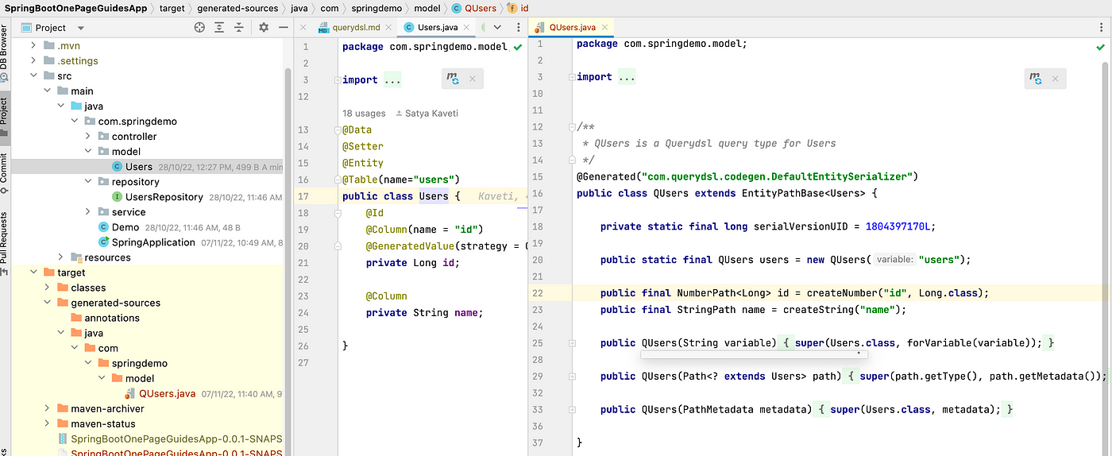

we have Users.java as Entity class

@Data  
@Setter  
@Entity  
@Table(name="users")  
public class Users {  
 @Id  
 @Column(name = "id")  
 @GeneratedValue(strategy = GenerationType.IDENTITY)  
 private Long id;  
  
 @Column  
 private String name;  
  
 @Column  
 private Double salary;  
}

Let us now create the UsersRepository interface which extends JpaRepository and the QuerydslPredicateExecutor

public interface UsersRepository extends JpaRepository<Users, Long> , QuerydslPredicateExecutor<Users> {  
   
}

TheQuerydslPredicateExecutor interface provides several overloaded methods that lets us allow executing Querydsl predicates. Following are the methods of QuerydslPredicateExecutor:

public interface QuerydslPredicateExecutor<T> {  
 Optional<T> findOne(Predicate predicate);  
 Iterable<T> findAll(Predicate predicate);  
 Iterable<T> findAll(Predicate predicate, Sort sort);  
 Iterable<T> findAll(Predicate predicate, OrderSpecifier<?>... orders);  
 Iterable<T> findAll(OrderSpecifier<?>... orders);  
 Page<T> findAll(Predicate predicate, Pageable pageable);  
 long count(Predicate predicate);  
 boolean exists(Predicate predicate);  
}

The methods in the **QuerydslPredicateExecutor** takes a Predicate and also provides an option to use pagination, sorting, ordering and so on.

we have Controller and save call will save 10 Users

@RestController  
@RequestMapping("/api")  
public class UsersController {  
  
 @Autowired  
 private UsersService service ;  
  
 // display list of users  
 @GetMapping("/all")  
 public List<Users> listUserss(Model model) {  
 System.out.println(" ===> listUserss");  
 return service.getAllUserss();  
 }  
  
 @GetMapping("/addall")  
 public String addDummyUsers() {  
 System.out.println(" ===> listUserss");  
 for(int i=0; i<10; i++){  
 Users user = new Users();  
 user.setName(nameGen());  
 user.setSalary(salaryGen());  
 System.out.println("added : "+user);  
 service.saveUser(user);  
 }  
 return "Users added";  
 }  
  
 @GetMapping("/querysln")  
 public String querysln() {  
 System.out.println(" ===> querysln");  
 return service.querySln();  
 }  
 private String nameGen()  
 {  
 String AlphaNumericStr = "ABCDEFGHIJKLMNOPQRSTUVWXYZSATYA";  
 StringBuilder s = new StringBuilder(6);  
 int i;  
 for ( i=0; i<8; i++) {  
 int ch = (int)(AlphaNumericStr.length() * Math.random());  
 s.append(AlphaNumericStr.charAt(ch));  
 }  
 return s.toString();  
 }  
 private Double salaryGen()  
 {  
 Random r = new Random();  
 int low = 5000;  
 int high = 90000;  
 int result = r.nextInt(high-low) + low;  
 return Double.parseDouble(result+"");  
 }  
}

We use EntityManager and UsersRepository to create Querydsl queries. ServiceImpl method

public String querySln() {  
 QUsers users = QUsers.users;  
  
 String result = "";  
  
 System.out.println(" -- users having salary greater than 10000 order by salary --");  
 result = result + "-- users having salary greater than 10000 order by salary --";  
 //BooleanExpression implements Predicate  
 //goe='greater than or equals'  
 BooleanExpression booleanExpression = QUsers.users.salary.goe(10000);  
 OrderSpecifier<Double> orderSpecifier = QUsers.users.salary.asc();  
 Iterable<Users> users1 = repository.findAll(booleanExpression, orderSpecifier);  
 for (Users user : users1) {  
 result = result + "\n " + user;  
 }  
  
 System.out.println(" -- users salary between 3000 and 5000 --");  
 result = result + "\n \n \n -- users salary between 3000 and 5000 --";  
 BooleanExpression booleanExpression2 = QUsers.users.salary.between(30000, 50000);  
 Iterable<Users> users3 = repository.findAll(booleanExpression2);  
 for (Users user : users3) {  
 result = result + "\n " + user;  
 }  
 System.out.println(" -- find users YNDFBTUG --");  
 result = result + "\n \n \n-- find users YNDFBTUG --";  
 BooleanExpression booleanExpression3 = QUsers.users.name.eq("YNDFBTUG");  
 Optional<Users> opt = repository.findOne(booleanExpression3);  
 result = result + "\n " + opt.get();  
  
 return result;  
 }

Sample Employee Pagable with SearchCriteria

public Page<EmployeeDto> findEmployee(Pageable pageRequest, SearchCriteriaDTO searchCriteria) {  
 QEmployee qEmployee = QEmployee.Employee;  
   
 BooleanBuilder builder = new BooleanBuilder();  
 builder.and(qEmployee.status.eq("PERMENENT");  
   
 if(!StringUtils.isEmpty(searchCriteria.getEmployeeId())) {  
 builder.and(qEmployee.employeeId.eq(searchCriteria.getEmployeeId()));  
 }  
   
 if(!StringUtils.isEmpty(searchCriteria.getRole())) {  
 builder.and(qEmployee.role.eq(searchCriteria.getRole()));  
 }  
   
 if(!StringUtils.isEmpty(searchCriteria.getName())) {  
 builder.and(qEmployee.name.containsIgnoreCase(searchCriteria.getName()));  
 }  
   
 JPAQuery<Employee> query = new JPAQuery<>(entityManager);  
 query.from(qEmployee);  
 query = query.where(builder);  
 Long totalCount = query.fetchCount();  
   
 query.offset(pageRequest.getOffset());  
 query.limit(pageRequest.getPageSize());  
 query.orderBy(qEmployee.reportId.desc());  
   
 List<Employee> employeeLst = query.fetch();  
 Type listType = new TypeToken<List<EmployeeDto>>() {}.getType();   
   
 ModelMapper modelMapper = mapperUtil.getEmployeeMapper();  
   
 List<EmployeeDto> returnValue = modelMapper.map(EmployeeLst, listType);  
 Page<EmployeeDto> result = new PageImpl(returnValue, pageRequest, totalCount);  
 return result;  
 }

Example Pageable search results with Employee Entity- Complete flow from Controller to Backend Repository

*/  
//1. Controller   
//==========================================  
public class EmployeeController {  
  
 @Autowired  
 private final EmployeeService employeeService;  
  
 @ApiOperation("Returns a page of all Employee list")  
 @ApiResponses(value = {@ApiResponse(code = 200, message = "Success"), @ApiResponse(code = 400, message = "Bad Request"), @ApiResponse(code = 500, message = "Internal Server Error"), @ApiResponse(code = 403, message = "Unauthorized")})  
 @PostMapping("/search")  
 public Page<EmployeeSearchResultsDto> searchAllEmployee(Pageable pageRequest, @RequestBody EmployeeSearchDto searchCriteria) {  
 return employeeService.searchAllEmployee(pageRequest, searchCriteria);  
 }  
}  
  
  
//==========================================  
//2.Service Class  
//==========================================  
 public Page<EmployeeSearchResultsDto> searchAllEmployee(Pageable pageRequest, EmployeeSearchDto searchCriteria) {  
 return employeeRepository.employeeSearchCriteria(pageRequest, searchCriteria);  
 }  
  
  
//==========================================  
//3.Repository Class which extends EmployeeRepositoryCustom,  
// - QuerydslPredicateExecutor<Employee>,  
// - QuerydslBinderCustomizer<QEmployee>  
//==========================================  
public interface EmployeeRepository extends RevisionRepository<Employee, Long, Long>, JpaRepository<Employee, Long>, EmployeeRepositoryCustom,  
 QuerydslPredicateExecutor<Employee>,  
 QuerydslBinderCustomizer<QEmployee> {  
  
 @Override  
 default void customize(QuerydslBindings bindings, QEmployee root) {  
 bindings.bind(String.class).first((StringPath path, String value) -> path.containsIgnoreCase(value));  
 }  
}  
  
  
  
//==========================================  
//4.EmployeeRepositoryCustom  
//==========================================  
public interface EmployeeRepositoryCustom {  
  
 Page<EmployeeSearchResultsDto> employeeSearchCriteria(Pageable pageRequest, EmployeeSearchDto searchCriteria);  
}  
  
  
  
//==========================================  
//5.Pagable Implementation EmployeeRepositoryCustomImpl  
//==========================================  
@Repository  
@Slf4j  
public class EmployeeRepositoryCustomImpl implements com.employee.dao.repository.EmployeeRepositoryCustom {  
  
 @PersistenceContext  
 private EntityManager entityManager;  
  
 @Autowired  
 private EmployeeSearchResultMapper employeeSearchResultMapper;  
  
  
 @Override  
 public Page<EmployeeSearchResultsDto> employeeSearchCriteria(Pageable pageRequest, EmployeeSearchDto searchCriteria) {  
  
 QEmployee qEmployee = QEmployee.employee;  
 BooleanBuilder builder = new BooleanBuilder();  
 applySearchCriteria(searchCriteria, qEmployee, builder);  
  
 JPAQuery<Employee> query = new JPAQuery<>(entityManager);  
 query = query.from(qEmployee);  
 query = query.where(builder);  
 Long totalCount = query.fetchCount();  
 query.offset(pageRequest.getOffset());  
 query.limit(pageRequest.getPageSize());  
 PathBuilder<Employee> entityPath = new PathBuilder<>(Employee.class, "employee");  
  
 for (Sort.Order order : pageRequest.getSort()) {  
 PathBuilder<Object> path = entityPath.get(order.getProperty());  
 query.orderBy(new OrderSpecifier(Order.valueOf(order.getDirection().name()), path));  
 }  
 List<Employee> result = query.fetch();  
 List<EmployeeSearchResultsDto> employeeDtoResult = employeeSearchResultMapper.toEmployeeSearchResultsDtoList(result);  
 return new PageImpl<>(employeeDtoResult, pageRequest, totalCount);  
  
 }  
  
  
 private void applySearchCriteria(EmployeeSearchDto searchCriteria, QEmployee qEmployee, BooleanBuilder builder) {  
 try {  
  
 if (Objects.nonNull(searchCriteria.getName()) && StringUtils.isNotBlank(searchCriteria.getName())) {  
 builder.and(qEmployee.name.containsIgnoreCase(searchCriteria.getName()));  
 }  
 if (Objects.nonNull(searchCriteria.getSalary())) {  
 builder.and(qEmployee.salary.eq(searchCriteria.getSalary()));  
 }  
 if (Objects.nonNull(searchCriteria.getCity()) && StringUtils.isNotBlank(searchCriteria.getCity())) {  
 builder.and(qEmployee.city.containsIgnoreCase(searchCriteria.getCity()));  
 }  
 } catch (Exception ex) {  
 log.error("Exception Occurred while getting search results", ex);  
  
 }  
 }  
  
}  
  
  
//==========================================  
//6.Search Results Mapper  
//==========================================  
@Mapper(componentModel = "spring")  
public interface EmployeeSearchResultMapper {  
  
 List<EmployeeSearchResultsDto> toEmployeeSearchResultsDtoList(List<Employee> employeeEntityList);  
  
 EmployeeSearchResultsDto toEmployeeSearchResultsDto(Employee employee);  
  
}

# SpringBoot Dynamic Task Scheduling

<https://satyacodes.gitlab.io/SpringBoot-Task-Scheduling-Guide.html>

<https://satyacodes.medium.com/springboot-task-scheduling-guide-dfbce8ae0019>

# Java – Create XML schema from DTO / Entity Classes using JAXB

JAXB provides a fast and convenient way to marshal (write) Java objects into XML and unmarshal (read) XML into objects. It supports a binding framework that maps XML elements and attributes to Java fields and properties using Java annotations.

## Maven Dependencies

<dependency>  
 <groupId>javax.xml.bind</groupId>  
 <artifactId>jaxb-api</artifactId>  
 <version>2.3.1</version>  
</dependency>  
<dependency>  
 <groupId>com.sun.xml.bind</groupId>  
 <artifactId>jaxb-core</artifactId>  
 <version>2.3.0.1</version>  
</dependency>  
<dependency>  
 <groupId>com.sun.xml.bind</groupId>  
 <artifactId>jaxb-impl</artifactId>  
 <version>2.3.3</version>  
</dependency>

## JAXB Annotations

JAXB uses Java annotations to augment the generated classes with additional information. Adding such annotations to existing Java classes prepares them for the JAXB runtime.

Let's take our Employee DTO and understand the JAXB annotations

@XmlRootElement  
@XmlAccessorType(XmlAccessType.***FIELD***)  
**public class** EmployeeDto {  
  
 **private** Long **id**;  
  
 @XmlElement(required = **true**)  
 **private** String **name**;  
  
 @XmlElement(name = **"salary"**, required = **true**)  
 **private** Double **salary**;  
  
 @XmlElement  
 **private** String **city**;  
  
 @XmlElement(required = **true**)  
 **private** AccountDto **account**;  
  
 @XmlElement  
 **private** List<DocumentDto> **documentList**;  
  
  
 **private** String **createdBy**;  
 **private** String **modifiedBy**;  
  
 **private** Date **createdDate**;  
 **private** Date **modifiedDate**;  
  
}

**@XmlRootElement**. This annotation should be applied to the class that you want to be treated as the root element when converting it to XML.

**@XmlAccessorType(XmlAccessType.FIELD)** to specify that JAXB should use field access for XML binding. This means that fields (instance variables) are directly used for reading and writing XML, rather than getter and setter methods

**@XmlType**: define the order in which the fields are written in the XML file

**@XmlTransient** annotation in JAXB is used to mark a class, field, or property as transient, indicating that it should be excluded from XML serialization and deserialization.

**@XmlElement** is an annotation used to indicate that the annotated field or property should be mapped to an XML element.

* **name="salary "** specifies the name of the XML element to which the field or property should be mapped. In this case, it's "**salary**."
* **required=true** indicates that the XML element is required in the XML document. If **required** is set to **true**, it means that the XML element must be present when marshalling (converting Java objects to XML) and unmarshalling (converting XML to Java objects). If the element is missing, it may result in an error.

## JAXB-2 Maven Plugin

This plugin uses the Java API for XML Binding (JAXB), version 2+, to generate Java classes from XML Schemas (and optionally binding files) or to create XML schema from an annotated Java class

Update maven Build plugin

<**build**>  
 <**plugins**>   
  
 <**plugin**>  
 <**groupId**>org.codehaus.mojo</**groupId**>  
 <**artifactId**>jaxb2-maven-plugin</**artifactId**>  
 <**version**>2.5.0</**version**>  
 <**executions**>  
 <**execution**>  
 <**id**>schemagen</**id**>  
 <**goals**>  
 <**goal**>schemagen</**goal**>  
 </**goals**>  
 </**execution**>  
 </**executions**>  
 <**configuration**>  
 <**sources**>  
 *<!-- Update XML DTOs location here -->* <**source**>src/main/java/com/employee/api/v1/model/dto</**source**>  
 </**sources**>  
 </**configuration**>  
 </**plugin**>  
  
 </**plugins**>  
</**build**>

**<source> - here we need to update Dto classes location**

At last, do mvn clean install

Now, we can see generated schema document inside target/

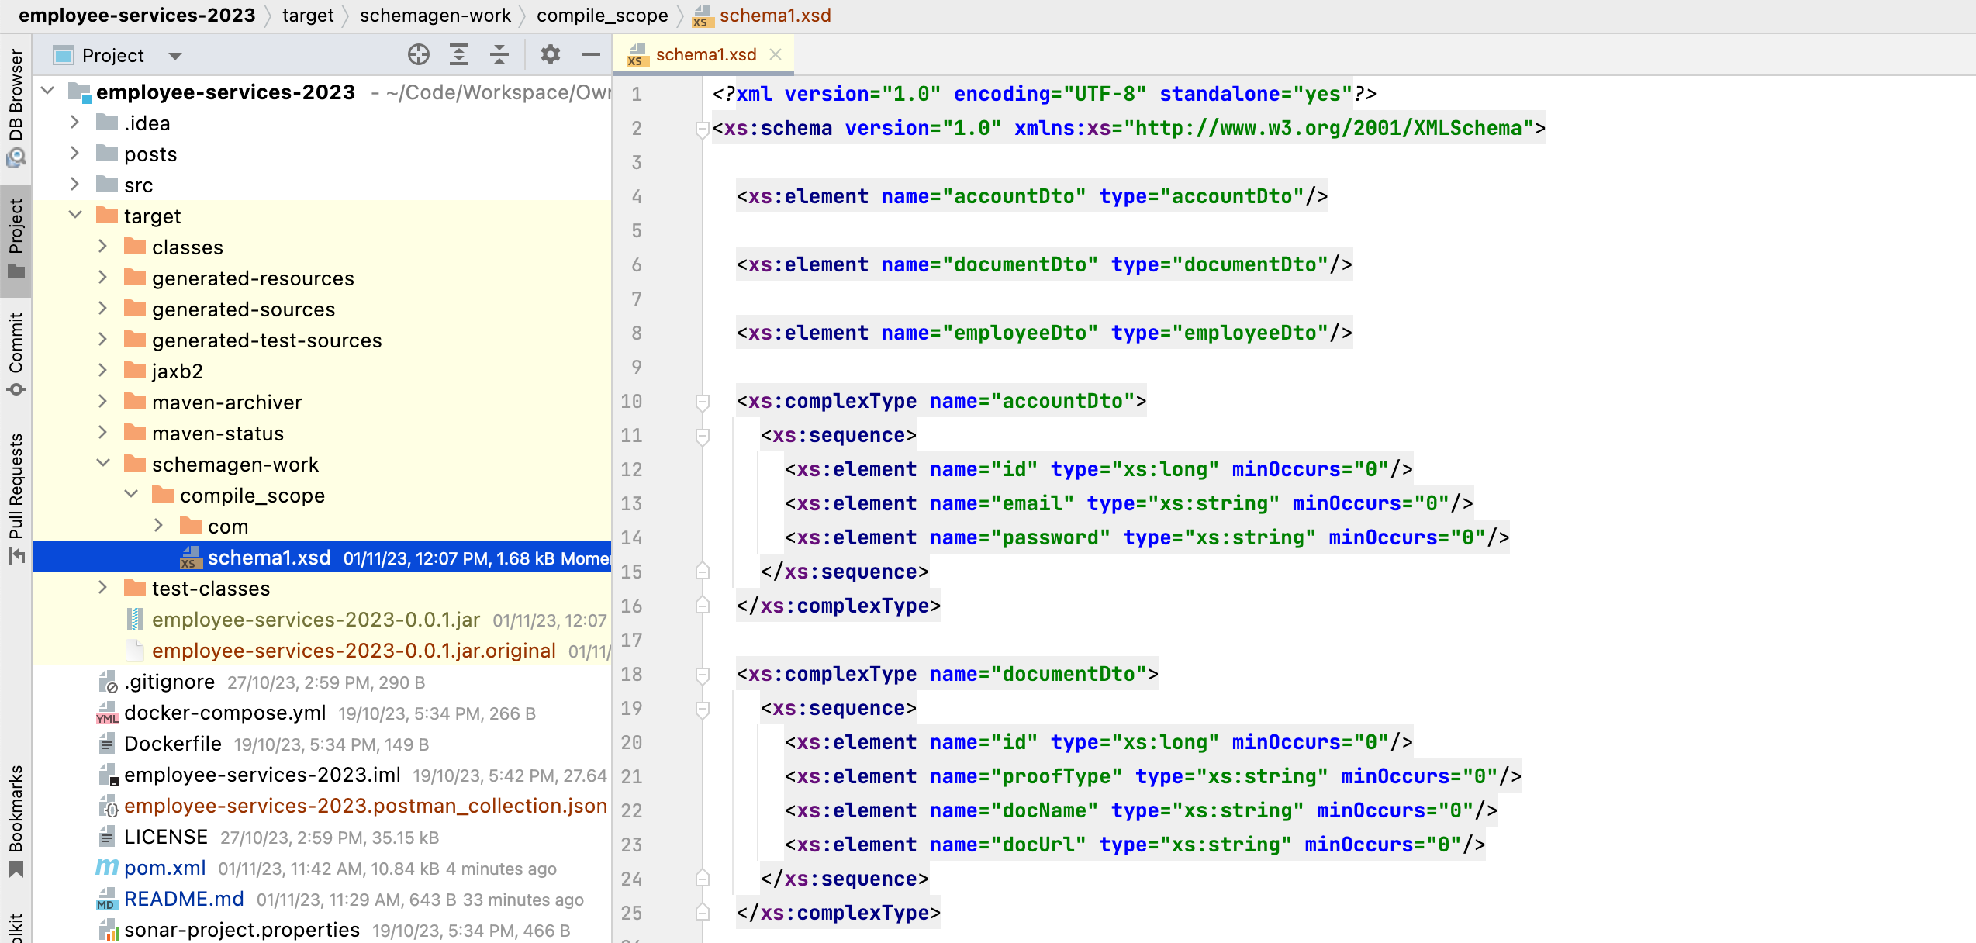

# SpringBoot – Custom exception handling with @ControllerAdvice

Before going further, Let’s see how we do validation in spring boot.

In Spring Boot, you can perform validation using the Java Bean Validation framework, which is based on the Java Validation API (JSR-380) and the **javax.validation** package

<dependency>

<groupId>org.springframework.boot</groupId>

<artifactId>spring-boot-starter-validation</artifactId>

</dependency>

To perform validation, we need to annotate the fields of the bean/dto class with validation annotations from the **javax.validation.constraints** package. For example, you can use **@NotNull**, **@Size**, **@Email**, and more to specify validation constraints.

@Data  
@JsonIgnoreProperties(ignoreUnknown = **true**)  
@NoArgsConstructor  
@AllArgsConstructor  
@Builder  
@XmlRootElement  
@XmlAccessorType(XmlAccessType.***FIELD***)  
**public class** EmployeeDto {  
  
 @XmlElement(required = **true**)  
 **private** Long **id**;  
  
 @XmlElement(required = **true**)  
 @NotNull  
 @Size(min = 4, max = 10)  
 **private** String **name**;  
  
 @XmlElement(name = **"salary"**, required = **true**)  
 @Digits(integer = 10, fraction = 2)  
 **private** Double **salary**;  
  
 @XmlElement  
 @Size(max = 20)  
 **private** String **city**;  
  
 @XmlElement(required = **true**)  
 **private** AccountDto **account**;   
}

To perform validation whenever user submits employee payload to API call, we need to annotate @Valid annotation against the dto parameter like below.

@ApiOperation(**"Create a new Employee or update exist "**)  
@PostMapping  
**public** EmployeeDto save(@RequestBody @Valid EmployeeDto employeeDto) {  
 **return employeeService**.save(employeeDto, id);  
}

Ok, lets run & check the validation messages.

Payload:

{

"name": "HYDGHAGHGHAHGAHGAHGAHGHYDGHAGHGHAHGAHGAHGAHG",

"salary": 25000,

"city": "HYDGHAGHGHAHGAHGAHGAHG",

"account": {

"email": "satya@gmail.com",

"password": "password",

"dob": "1990-10-27"

},

Response:

{

"exception": "org.springframework.web.bind.MethodArgumentNotValidException",

"fingerprint": "036d809a-175d-4db1-ba77-9c5258c1e244",

"errors": [

{

"code": "javax.validation.constraints.Size.message",

"arguments": {

"min": 0,

"max": 20,

"invalid": "HYDGHAGHGHAHGAHGAHGAHG",

"property": "city"

},

"message": "size must be between 0 and 20"

}

],

"status": "Bad Request"

}

Okay, city allows max of 10 char, buts its more than that – and we got the error.

But, This is NOT READABLE, the end user don’t want this technical details. Just want what’s the field & what he need to pass.

This we can achive by implementing Custom exception handling with **@ControllerAdvice**

## Custom exception handling with @ControllerAdvice

**@ControllerAdvice** is an annotation in Spring Boot that allows you to define global exception handling for your controllers. You can use it to handle exceptions that occur in multiple controllers or to provide a centralized place for handling exceptions throughout your application.

1. Create a custom exception class. I want to display HTTP Status with all the error messages.

**public class** ErrorDetails {  
  
 **private** HttpStatus **code**;  
  
 **private** List<String> **message**;  
  
}

2. Create a **CustomExceptionHandler** class & annotate with **@ControllerAdvice.**  It contains methods for handling specific exceptions. You can specify the exception types to handle in the **@ExceptionHandler** annotation on each method.

Iam also extending  **ResponseEntityExceptionHandler &** overridinghandleMethodArgumentNotValid()**.** This is usefull in case of Rest API, because It provides a way to handle exceptions and customize the HTTP response entity that is returned to the client.

@ControllerAdvice  
**public class** CustomExceptionHandler **extends** ResponseEntityExceptionHandler {  
  
 @ExceptionHandler(EntityNotFoundException.**class**)  
 **public final** ResponseEntity<Object> handleDBEntityNotFound(EntityNotFoundException ex, WebRequest webRequest) {  
 ErrorDetails error = **new** ErrorDetails();  
 error.setCode(HttpStatus.***INTERNAL_SERVER_ERROR***);  
 List<String> message = **new** ArrayList<>();  
 message.add(ex.getMessage());  
 error.setMessage(message);  
 **return new** ResponseEntity<Object>(error, error.getCode());  
 }  
  
  
 @Override  
 **protected** ResponseEntity<Object> handleMethodArgumentNotValid(MethodArgumentNotValidException ex, HttpHeaders headers, HttpStatus status, WebRequest request) {  
 ErrorDetails error = **new** ErrorDetails();  
 error.setCode(HttpStatus.***BAD_REQUEST***);  
 List<String> message = **new** ArrayList<String>();  
  
 List<String> collect = ex.getBindingResult().getFieldErrors().stream().filter(Objects::*nonNull*)  
 .map(m -> (m.getField() + **" "** + m.getDefaultMessage())).collect(Collectors.*toList*());  
 message.addAll(collect);  
 error.setMessage(message);  
 **return new** ResponseEntity<Object>(error, HttpStatus.***BAD_REQUEST***);  
 }  
}

That’s it now run the application again with the same payload.

{

"code": "BAD_REQUEST",

"message": [

"city size must be between 0 and 20",

"name size must be between 4 and 10"

]

}

That’s all on a high level.

# SpringBoot — export Java Objects to JSON & JSON to Object

Its very simple tutorial, wrote for reference purpose.

Im using Jackson ObjectMapper to read and write JSON data into Java Objects

Let’s add dependency

<dependency>  
 <groupId>com.fasterxml.jackson.core</groupId>  
 <artifactId>jackson-databind</artifactId>  
 <version>2.13.0</version>   
</dependency>

using ObjectMapper class for marshalling and unmarshalling the JSON.

ObjectMapper mapper = new ObjectMapper();  
  
//Java Object -> JSON  
String json = mapper.writeValueAsString(employeeDto);  
  
//JSON -> Java Object  
EmployeeDto dto = mapper.readValue(json, EmployeeDto.class);

Export Java Objects to JSON file

@GetMapping("/json/export")  
public ResponseEntity<Resource> exportEmployeesToJson() {  
 try {  
 List<EmployeeDto> employees = employeeService.getAllEmployees();  
 String jsonData = objectMapper.writeValueAsString(employees);  
 ByteArrayResource resource = new ByteArrayResource(jsonData.getBytes());  
 String fileName = "employees_" + LocalDateTime.now() + ".json";  
 return ResponseEntity.ok().header(HttpHeaders.CONTENT_DISPOSITION, "attachment; filename=\"" + fileName + "\"").contentLength(resource.contentLength()).contentType(MediaType.APPLICATION_JSON).body(resource);  
 } catch (Exception e) {  
 log.error(e.getMessage(), e); }  
}

Import JSON file and convert in to Java Entity

@PostMapping("/json/import")  
public EmployeeDto importEmployees(MultipartFile file) {  
 try {  
 String jsonContent = new String(file.getBytes());  
 EmployeeDto employeeDto = objectMapper.readValue(jsonContent, new TypeReference<>() {  
 });  
 return employeeService.save(employeeDto, employeeDto.getId());  
 } catch (Exception e) {  
 log.error("error : {}", e.getMessage());  
 }  
}

//Service Class

public class EmployeeServiceImpl implements EmployeeService {  
  
 @Autowired  
 private EmployeeRepository employeeRepository;  
  
 @Autowired  
 private EmployeeMapper employeeMapper;  
  
 private final ObjectMapper objectMapper;  
  
 @Override  
 public EmployeeDto save(EmployeeDto employeeDto, Long employeeId) {  
 log.info("save start :::: employeeId:{}", employeeId);  
 try {  
 Boolean createRequest = StringUtils.isEmpty(employeeId) ? Boolean.TRUE : Boolean.FALSE;  
 Employee employee = getEmployee(employeeId, createRequest);  
 employeeMapper.toEntity(employeeDto, employee);  
 Employee entity = employeeRepository.save(employee);  
 return employeeMapper.toDto(entity);  
 } catch (Exception ex) {  
 log.error("Error while saving employee", ex);  
 throw new BusinessException("Save Failed");  
 }  
 }  
  
  
 @Override  
 public List<EmployeeDto> getAllEmployees() {  
 List<Employee> employees = employeeRepository.findAll();  
 return employeeMapper.mapEntityListToDtoListForEmployee(employees);  
 }  
  
}

# Spring Boot Role-based Authentication with Keycloak

## Keycloak Intro

Keycloak is an open-source identity and access management (IAM) tool. Keycloak implements almost all standard IAM protocols like OAuth 2.0, OpenID, and SAML.

Keycloak provides the following features:

* OpenID Connect support.
* OAuth 2.0 support.
* SAML support.
* Single-Sign On and Single-Sign Out for browser applications.
* Social Login - Enable login with Google, GitHub, Facebook, Twitter, and other social networks.
* User Federation - Sync users from LDAP and AD servers & [many more(Read More).](https://www.keycloak.org/docs/latest/server_admin/index.html) [**Cloud Doc**](https://documentation.cloud-iam.com/?pk_vid=b1c0510047749b951699432592034cf4)

In our application, we are using an OAuth library to integrate Keycloak with our application. 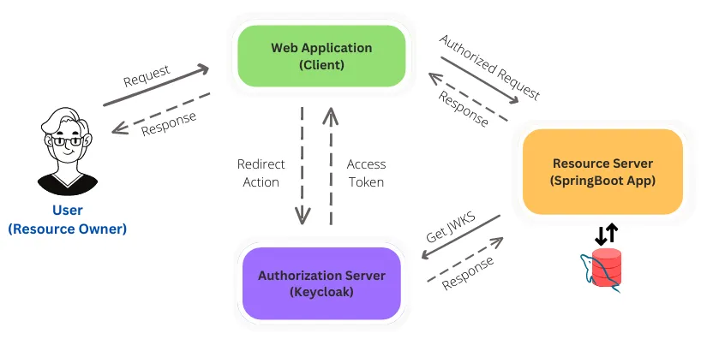

## Setting up a Keycloak server

Setting up a Keycloak server Locally

* Download Distribution powered by Quarkusfrom here : <https://www.keycloak.org/downloads>
* Extract, go to bin run ./kc.sh start-dev
* The default port is 8080. Open <http://0.0.0.0:8080/> in browser

Setting up a Keycloak Online Cloud server Free

<https://www.cloud-iam.com/>

* Set up a free cluster, you will get credentials via email.
* Login to the admin account & update the password.

## Configuring Keycloak server

**1. Creating a Realm**

From the Master drop-down menu, click Add Realm and typespringboot-realm in the name field and click Create button.

**2. Creating a client**

A client represents a resource that can be accessed by certain users.

Provide ClineID & keep the default configs and save.

Then we need to provide a **Valid Redirect URIs**– for this add springboot service url

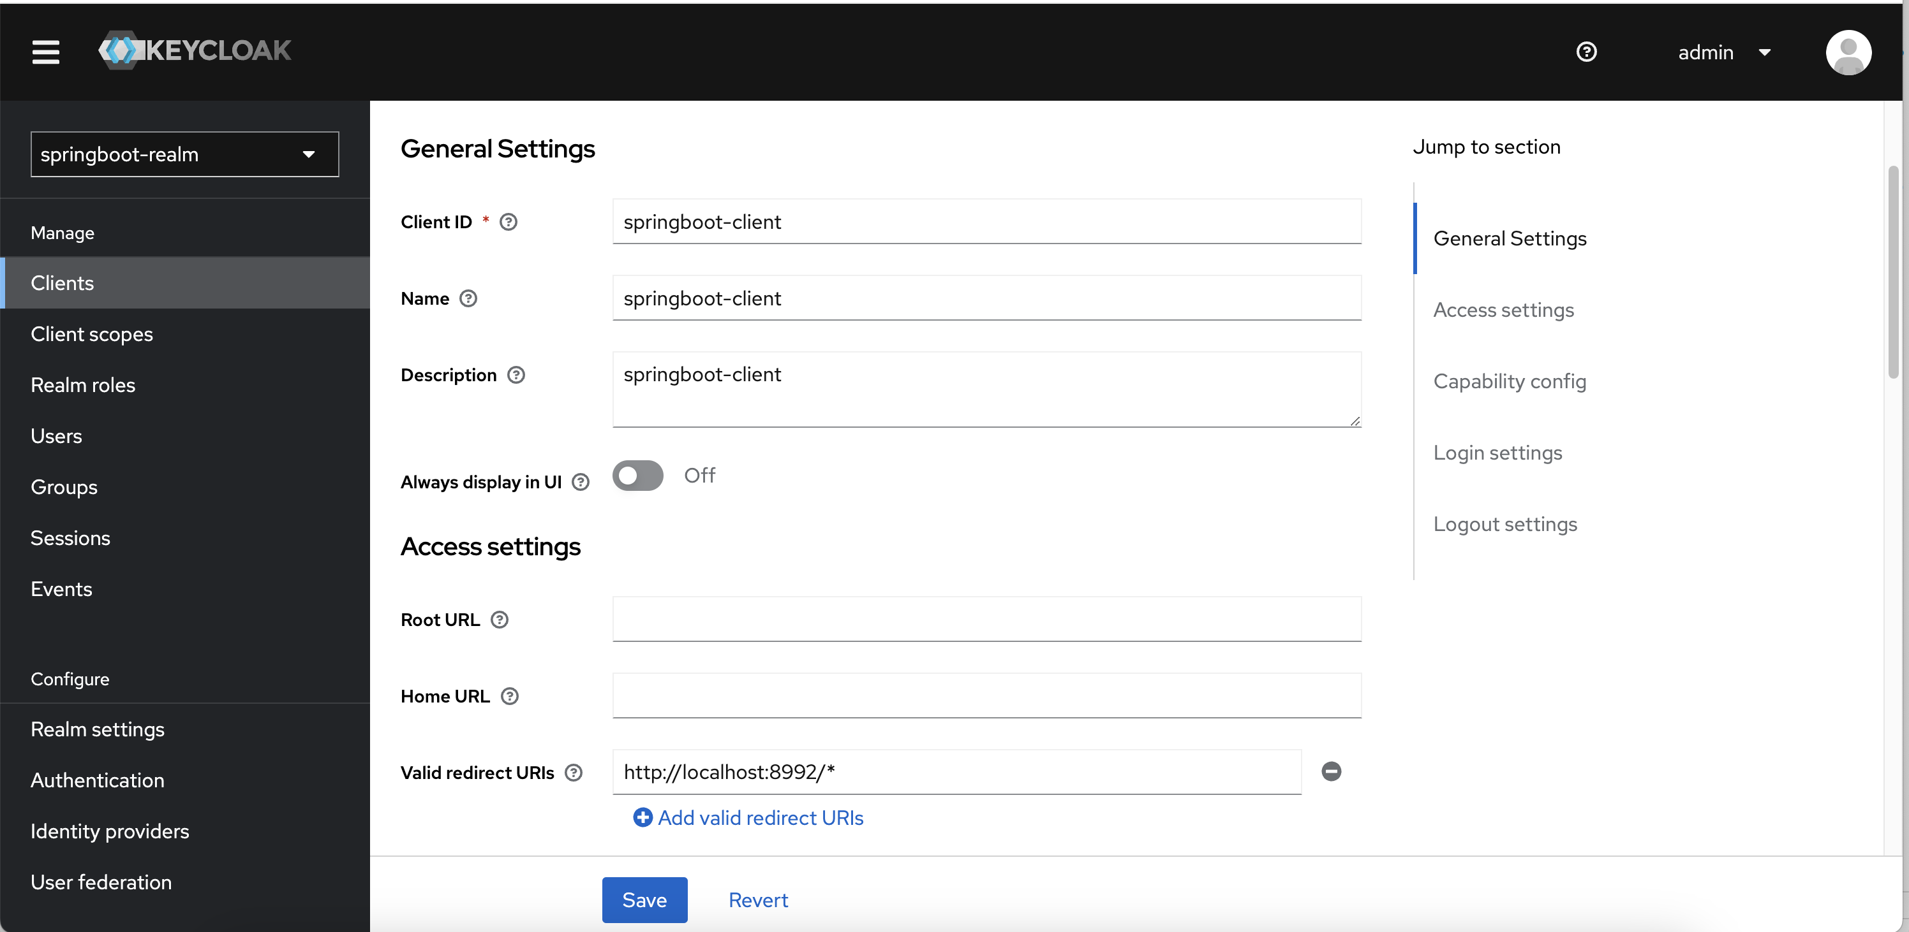

**3. Creating Roles**

Mainly there are 2 role types in Keycloak.

1. **Realm Role:** It is a global role, belonging to that specific realm. This can access from any client and map it to any user. Global Admin and Admin roles can be considered examples of this.
2. **Client Role:** It is a role which belongs only to that specific client. These roles cannot be accessed from a different client. This can only map to the users from that client. *Example Roles:* Employee, User etc

**Client Role:** : select the client springboot-client and click Roles Press the Create role button. Create admin, user roles here.

**Realm roles:**  Navigate to the *Realm Roles* page to create roles.

Now, add clinet roles to releam roles. For that Click one of the roles and select Add associated roles in the Action drop down.

**4. Creating Users**

Create users & assign roles to them.

Set password for the users Click the **Credentials** tab and press **Set password**button.

## Generating Access tokens with Keycloak API

You can send a post request to this token endpoint to get a token. You can use one of the users we have already created ( user1 , user2 or admin ) as credentials.

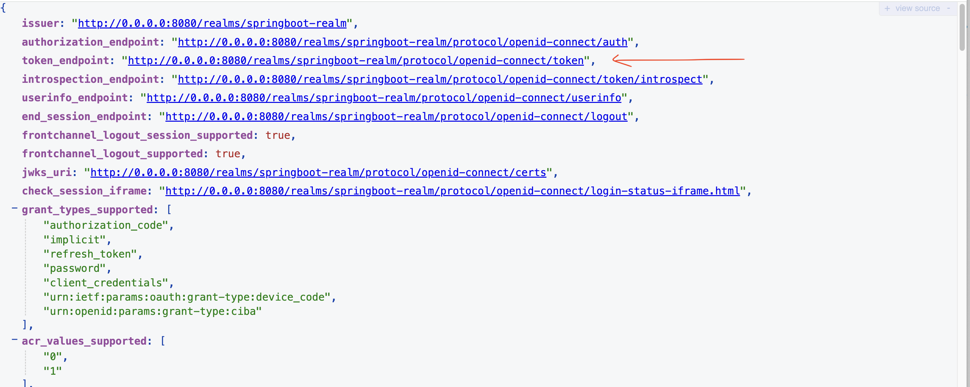

Use Postman to get the token with below payload.

curl --location 'http://localhost:8080/realms/springboot-realm/protocol/openid-connect/token' \

--header 'Content-Type: application/x-www-form-urlencoded' \

--data-urlencode 'grant_type=password' \

--data-urlencode 'client_id=springboot-client' \

--data-urlencode 'username=user1' \

--data-urlencode 'password=password'

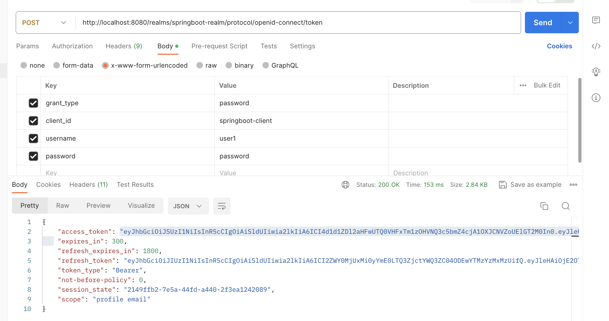

Now you can copy that access_token and decode it using the [jwt.io](https://jwt.io/) website to see the information inside that.

#### Getting refresher token

If the access_token expired, you can send a request to the same endpoint with refresh_token & grant_type as refresh_token as below.

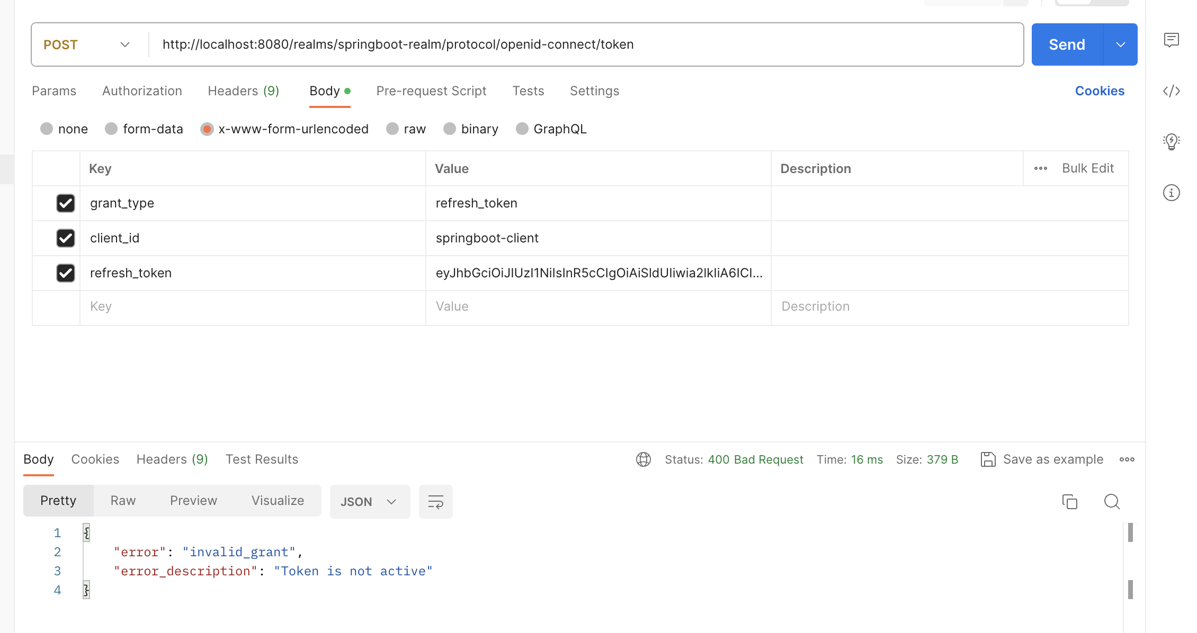

# Spring Security

<https://docs.spring.io/spring-security/reference/servlet/getting-started.html>

Add Security Dependency.

<dependency>

<groupId>org.springframework.boot</groupId>

<artifactId>spring-boot-starter-security</artifactId>

</dependency>

Run the Application & you can see the default security password on the console

security password: a134381d-3db8-4d6c-9f62-8d5010c67a0f

Let’s Hit Any API. You will get **unauthorized** response.

Select Basic Auth from Postman, fill details & hit again

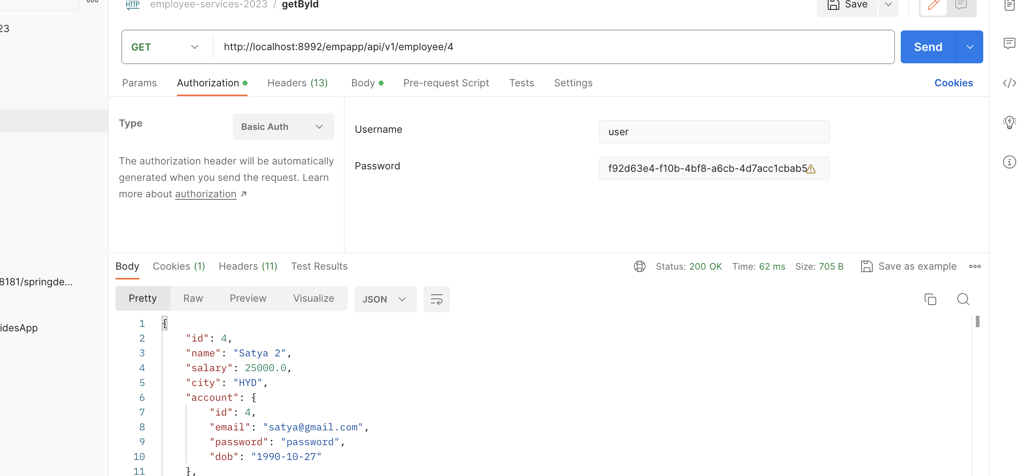

This is the default Spring Security configuration provided by Spring.

@EnableWebSecurity

@Configuration

public class DefaultSecurityConfig {

@Bean

@ConditionalOnMissingBean(UserDetailsService.class)

InMemoryUserDetailsManager inMemoryUserDetailsManager() {

String generatedPassword = *// ...;*

return new InMemoryUserDetailsManager(User.withUsername("user")

.password(generatedPassword).roles("ROLE_USER").build());

}

@Bean

@ConditionalOnMissingBean(AuthenticationEventPublisher.class)

DefaultAuthenticationEventPublisher defaultAuthenticationEventPublisher(ApplicationEventPublisher delegate) {

return new DefaultAuthenticationEventPublisher(delegate);

}

}

1. Adds the @EnableWebSecurity annotation.
2. Publishes a [UserDetailsService](https://docs.spring.io/spring-security/reference/servlet/authentication/passwords/user-details-service.html) @Bean with a username of user and a randomly generated password that is logged to the console
3. Publishes an [AuthenticationEventPublisher](https://docs.spring.io/spring-security/reference/servlet/authentication/events.html) @Bean for publishing authentication events

## 1.Username/Password Authentication (In Memmory)

Lets implement our own Authentication mechanism.

Steps involved for implementing our own Security Configuration

1. Create **SecurityConfig** class & annotate with @Configuration, @EnableWebSecurity
2. Configure **SecurityFilterChain** with URL’s & its access permissions
3. Configure **UserDetailsService** bean with user deatils
4. Configure **AuthenticationManager** bean with AuthenticationProvider & PasswordEncoder details.
5. Configure **PasswordEncoder** bean

@Configuration  
@EnableWebSecurity  
**public class** SecurityConfig {  
 @Bean  
 **public** SecurityFilterChain securityFilterChain(HttpSecurity http) **throws** Exception {  
 http.authorizeHttpRequests((authorize) -> authorize.anyRequest().authenticated())  
 .httpBasic(Customizer.*withDefaults*())  
 .formLogin(Customizer.*withDefaults*());  
  
 **return** http.build();  
 }  
  
 @Bean  
 **public** UserDetailsService userDetailsService() {  
 UserDetails userDetails = User.*withDefaultPasswordEncoder*()  
 .username(**"user"**)  
 .password(**"password"**)  
 .roles(**"USER"**)  
 .build();  
  
 **return new** InMemoryUserDetailsManager(userDetails);  
 }  
  
 @Bean  
 **public** AuthenticationManager authenticationManager(UserDetailsService userDetailsService, PasswordEncoder passwordEncoder) {  
 DaoAuthenticationProvider authenticationProvider = **new** DaoAuthenticationProvider();  
 authenticationProvider.setUserDetailsService(userDetailsService);  
 authenticationProvider.setPasswordEncoder(passwordEncoder);  
 **return new** ProviderManager(authenticationProvider);  
 }  
   
 @Bean  
 **public** PasswordEncoder passwordEncoder() {  
 **return** PasswordEncoderFactories.*createDelegatingPasswordEncoder*();  
 }  
}

Now check the console, it won't print password now.

Because we override the SecurityConfig, so now instead of generated password, we need to pass our own password, which is **password** in the above code.

This type of Step of authentication also called as in memory authentication. Because we are passing username and password in the code itself.

Now it will register the default username and password with UserDetialsService.

Now We need to implement AuthenticationManager by passing UserDetailsService & PasswordEncoder

* **SecurityFilterChain** in Spring Security is a key component that allows you to define and configure a chain of filters for handling various aspects of security in a Spring Security-enabled application
* **AuthenticationManager** is a crucial component responsible for authenticating users. When a user attempts to log in, the **AuthenticationManager** uses various authentication providers to validate the user's credentials.
* **DaoAuthenticationProvider** : is one of the authentication providers provided by Spring Security. It's designed to handle authentication using a data access object (DAO) to retrieve user details from a a database/local objects.
* **PasswordEncoder:** is an interface in Spring Security that provides a way to encode (hash) and verify passwords.

## SpringBoot Example

<https://sultanov.dev/blog/migrate-from-spring-security-oauth-to-keycloak/>

| **Methods** | **Urls** | **Actions** |
| --- | --- | --- |
| POST | /api/auth/signup | signup new account |
| POST | /api/auth/login | login an account |
| GET | **api/v1/employee/search** | public access |
| GET | GET, UPDATE | access User’s content |
| GET | ADD, DELETE | access Admin’s content |

## Ref.

<https://www.bezkoder.com/spring-boot-jwt-authentication/>

<https://javainfinite.com/spring-boot/integrate-spring-boot-with-keycloak-example/>

<https://www.baeldung.com/spring-boot-keycloak>

<https://webcache.googleusercontent.com/search?q=cache:https://medium.com/geekculture/using-keycloak-with-spring-boot-3-0-376fa9f60e0b>

# Spring Boot Cache

Before going SpringBoot cache mechanisum, let understand whats the Cache is.

* Cache is a part of temporary memory (RAM). It lies between the application and the persistent database.
* Caching is a mechanism used to increase the performance of a system. It is a process to store and access data from the cache.
* It stores the recently used data. This helps to reduces the number of database hits as much as possible.

### Types of Caching

There are four types of caching are as follows :

1. Database Caching.
2. In-memory Caching.
3. Web Server Caching.
4. CDN Caching

1. Database Caching:

Hibernate first level cache is an example of database caching.

2. In-memory Caching:

In this type of caching, data is stored in RAM. EhCache and Redis are examples of in-memory caching. EhCahe is a simple in-memory cache while Redis is advanced.

3. Web Server Caching :

It is cached for the first time when a user visits the page. If the user requests the same next time, the cache serves a copy of the page.

4. CDN Caching (Content Delivery Network) :

It improves delivery of the content by replicating common requested files such as Html Pages, images, videos, etc. across distributed set of caching servers.

In SpringBoot we use mostly use Database Caching & In-memory Caching

## Database Cache

Take Hibernate, Every fresh session having its own cache memory, Caching is a mechanism for storing the loaded objects into a cache memory.

The advantage of cache mechanism is, whenever again we want to load the same object from the database then instead of hitting the database once again, it loads from the local cache memory only, so that the no. of round trips between an application and a database server got decreased.

It means caching mechanism increases the performance of the application.

In hibernate we have two levels of caching

* First Level Cache (Session Cache)
* Second Level Cache (Session Factory Cache/ JVM Level Cache)

1.First Level Cache

* By default, for each hibernate application, the first level cache is automatically enabled. We can’t Enable/Disable first level cache
* the first level cache is associated with the session object and scope of the cache is limited to one session only
* When we load an object for the first time from the database then the object will be loaded from the database and the loaded object will be stored in the cache memory maintained by that session object
* If we load the same object once again, with in the same session, then the object will be loaded from the local cache memory not from the database
* If we load the same object by opening other session, then again the object will load from the database and the loaded object will be stored in the cache memory maintained by this new session

Example:

Session session = factory.openSession();

Object ob1 = session.get(Actor.class, new Integer(101)); //1

Object ob2 = session.get(Actor.class, new Integer(101));//2

Object ob3 = session.get(Actor.class, new Integer(101));//3

session.close();//4

Session ses2 = factory.openSession();

Object ob5 = ses2.get(Actor.class, new Integer(101));//5

1, We are loaded object with id 101, now it will load the object from the database only as its the first time, and keeps this object in the session cache

2,3 i tried to load the same object 2 times, but here the object will be loaded from the stored cache only not from the database, as we are in the same session

4, we close the first session, so the cache memory related this session also will be destroyed

5, again i created one new session and loaded the same object with id 101, but this time hibernate will loads the object from the database

if we want to remove the objects that are stored in the cache memory, then we need to call either evict() or clear() methods

2.Second Level Cache

Whenever we are loading any object from the database, then hibernate verify whether that object is available in the local cache(first level cache) memory of that particular session, if not available then hibernate verify whether the object is available in global cache(second level cache), if not available then hibernate will hit the database and loads the object from there, and then first stores in the local cache of the session , then in the global cache

SessionFactory holds the second level cache data. It is global for all the session objects and not enabled by default.

Different vendors have provided the implementation of Second Level Cache

1. EH Cache (Basic In-Memory)
2. Redis Cache (Advanced In-Memory)
3. Memcached
4. JBoss Cache

## SpringBoot Cache API (Common for Both EhCache & Redis)

Spring boot provides a Cache Abstraction API that allow us to use different cache providers to cache objects.

When the caching is enabled then the application first looks for required object in the cache instead of fetching from database. If it does not find that object in cache then only it access from database.

## Spring Boot Caching Annotations

1. @EnableCaching (Class Level)

It is a class level annotation. It is used to enable caching in spring boot application. By default it setup a CacheManager and creates in-memory cache using ConcurrentHashMap.

We can specify this in SpringBoot main Application class & Configuration class

//Application.java

@EnableCaching  
**public class** Application {  
 **public static void** main(String[] args) {  
 SpringApplication app = **new** SpringApplication(Application.**class**);

}

}

//CacheConfig.java

@Configuration  
@EnableCaching  
**public class** CacheConfig {  
  
}

2. @Cacheable

Cacheable  annotation is used to mark a method as cacheable. When a method is called, its result is stored in the memory cache. Subsequent invocations of the method with the same provided arguments will retrieve the cached result instead of invoking the method again.

@Cacheable(“employees”)  
public Employee findById(int id) {  
// some code  
}

* employees: name of the cache

|  |  |
| --- | --- |
| **parameter** | **Description** |
| value / cacheNames | Name of the cache in where results of method execution are stored. |
| key | The key for the cache entries as [Spring Expression Language (SpEL)](https://springframework.guru/introduction-spring-expression-language-spel/). If the parameter is not specified, a key is created for all method parameters by default. |
| keyGenerator | Name of a bean that implements the KeyGenerator interface and thus allows the creation of a user-defined cache key. |
| condition | Condition as Spring Expression Language (SpEL) that specifies when a result is to be cached. |
| unless | Condition as Spring Expression Language (SpEL) that specifies when a result should not be cached. |

3. @CachePut

It is a method level annotation. It is used to update the cache before invoking the method.

4. @CacheEvict

It is a method level annotation. It is used to remove the data from the cache.

5. @Caching

Let’s say you have a scenario where you want to use multiple annotations of the same type for caching a method. @Caching annotations allow you to use group multiple cache-related annotations together.

@Caching(evict = {  
@CacheEvict(“address”),   
@CacheEvict(value=“employee”, key=”#employee.id”)  
})  
public Employee getEmployee(Employee employee) {  
// some code  
}

**6. @CacheConfig**

It is a class level annotation. It is used to share **common properties** such as cache name, cache manager to all methods annotated with cache annotations.

When a class is declared with this annotation then it provides default setting for any cache operation defined in that class. Using this annotation, we do need to declare things multiple times.

For example,

@Service  
@CacheConfig(cacheNames=”employees”)  
public class EmployeeService {

@Cacheable  
 public Employee findById(int id) {  
 // some code  
 }  
}

## **Spring Boot Cache Providers**

The cache providers allow us to configure cache transparently and explicitly in an application.

The following steps are needed in order to configure any of these cache providers :

1. Add the annotation @EnableCaching in the configuration file.
2. Add the required **caching** mavendependencies
3. Add the configuration.xml for the cache provider in the root classpath.

The following are the cache provider supported by Spring Boot framework :

1. JCache (JSR-107)
2. **EhCache**
3. Hazelcast
4. Infinispan
5. Couchbase
6. **Redis**
7. Caffeine

EhCache

The EhCache is an open source Java based cache used to boost performance. It stores the cache in memory and disk (SSD).

EhCache used a file called **ehcache.xml**. The **EhCacheCacheManager** is automatically configured if the application found the file on the classpath.

If we want to use EhCache then we need to add the following dependency :

<dependency>  
 <groupId>org.ehcache</groupId>  
 <artifactId>ehcache</artifactId>  
</dependency>

**Redis**

Redis is a popular in-memory data structure. It is a keystore-based data structure which is used to persist data.

The **RedisCacheManager** is automatically configured when we configure **Redis**. The default configuration is set by using property **spring.cache.redis.\***.

If we want to use Redis then we need to add the following dependency :

<dependency>  
 <groupId>org.springframework.boot</groupId>  
 <artifactId>spring-boot-data-redis</artifactId>  
</dependency>

## SpringBoot + EhCache Example

1. Add Maven Dependencies

*<!-- EhCache -->*<**dependency**>  
 <**groupId**>org.springframework.boot</**groupId**>  
 <**artifactId**>spring-boot-starter-cache</**artifactId**>  
</**dependency**>  
<**dependency**>  
 <**groupId**>javax.cache</**groupId**>  
 <**artifactId**>cache-api</**artifactId**>  
 <**version**>1.1.1</**version**>  
</**dependency**>  
<**dependency**>  
 <**groupId**>org.ehcache</**groupId**>  
 <**artifactId**>ehcache</**artifactId**>  
 <**version**>3.8.1</**version**>  
</**dependency**>  
*<!-- EhCache -->*

2. add ext/ehcache.xml file in resources folder with Cache details

*<?***xml version="1.0" encoding="UTF-8"***?>*<**config xmlns:xsi="http://www.w3.org/2001/XMLSchema-instance"  
 xmlns:jsr107="http://www.ehcache.org/v3/jsr107"   
 xmlns="http://www.ehcache.org/v3"  
 xsi:schemaLocation="  
 http://www.ehcache.org/v3 http://www.ehcache.org/schema/ehcache-core-3.6.xsd  
 http://www.ehcache.org/v3/jsr107 http://www.ehcache.org/schema/ehcache-107-ext-3.6.xsd"**>  
   
 <**service**>  
 <**jsr107:defaults enable-management="true" enable-statistics="true"**/>  
 </**service**>  
   
 <**persistence directory="./cache"**/>  
   
 <**cache alias="GenericCache" uses-template="generic-cache"**></**cache**>  
 <**cache alias="PreAuthUsers" uses-template="preauthusers-cache"**></**cache**>  
 <**cache alias="employees" uses-template="employees-cache"**></**cache**>  
   
 *<!-- Cache Templates-->* <**cache-template name="generic-cache"**>  
 <**expiry**>  
 <**tti unit="seconds"**>300</**tti**>  
 </**expiry**>  
 <**heap unit="entries"**>2000</**heap**>  
 </**cache-template**>  
  
 <**cache-template name="preauthusers-cache"**>  
 <**expiry**>  
 <**tti unit="seconds"**>300</**tti**>  
 </**expiry**>  
 <**heap unit="entries"**>2000</**heap**>  
 </**cache-template**>  
  
  
 <**cache-template name="employees-cache"**>  
 <**expiry**>  
 <**tti unit="seconds"**>300</**tti**>  
 </**expiry**>  
 <**heap unit="entries"**>2000</**heap**>  
 </**cache-template**>  
</**config**>

3. add ext/ehcache.xml classpath to application.yaml configuration.

**spring**:  
 **cache**:  
 **jcache**:**config**: classpath:ext/ehcache.xml

2. Create CacheConfig Class & Add @EnableCaching

@Configuration  
@EnableCaching  
**public class** CacheConfig {  
  
}

3.Open Service Class & add appropriate Cache annotations on the top of the methods.

@Override  
@Cacheable(value = **"employees"**, key = **"#id"**)  
**public** EmployeeDto getEmployeeById(Long id) {  
 **var** entity = **employeeRepository**.findById(id).orElseThrow(() -> **new** EntityNotFoundException(Employee.**class**, id));  
 **return employeeMapper**.toDto(entity);  
}  
  
@Override  
@Cacheable(value = **"employees"**)  
**public** List<EmployeeDto> getAllEmployees() {  
 List<Employee> employees = **employeeRepository**.findAll();  
 **return employeeMapper**.mapEntityListToDtoListForEmployee(employees);  
}  
  
  
@Override  
@Transactional(propagation = Propagation.***REQUIRES_NEW***)  
@CacheEvict(cacheNames = **"employees"**, allEntries = **true**)  
**public void** delete(Long employeeId) {  
 **try** {  
 **var** entity = **this**.**employeeRepository**.findById(employeeId).orElseThrow(() -> **new** EntityNotFoundException(Employee.**class**, employeeId));  
 **employeeRepository**.delete(entity);  
 } **catch** (Exception ex) {  
 ***log***.error(**"Error while deleting"**, ex);  
 **throw** ex;  
 }  
}

Yup! That’s all. Call the API now & check the logs. Or you can use below API to get cached data.

@RestController  
@RequestMapping(**"/cache"**)  
@Slf4j  
**public class** CacheController {  
 @Autowired  
 CacheManager **cacheManager**;  
  
 @GetMapping(**"/all"**)  
 **public** Map<String, Object> getAllCachedData() {  
 Map<String, Object> cachedDataMap = **new** HashMap<>();  
  
 *// Get the names of all caches managed by the CacheManager* **for** (String cacheName : **cacheManager**.getCacheNames()) {  
 Cache cache = **cacheManager**.getCache(cacheName);  
 ***log***.info(**"Cache Name: {} , Cache: {} "**, cacheName, **cacheManager**);  
  
 cachedDataMap.put(cacheName, cache);  
 }  
 **return** cachedDataMap;  
 }  
}

## SpringBoot + Redis Cache Example

First You need to Install Redis Server in your system. Default Running in **127.0.0.1:6379**

satyakaveti@Satyas-MacBook-Pro-2 ~ % brew services info redis

**redis** (homebrew.mxcl.redis)

Running: **✔**

Loaded: **✔**

Schedulable: **✘**

User: satyakaveti

PID: 911

1. Add maven dependency

*<!-- redis -->*<**dependency**>  
 <**groupId**>org.springframework.boot</**groupId**>  
 <**artifactId**>spring-boot-starter-data-redis</**artifactId**>  
</**dependency**>

2. Update application.yaml configuration.

spring:  
 cache:  
 type: redis  
 host: localhost  
 port: 6379  
 redis:  
 time-to-live: 60000

** Make sure all the DTO classes implements **Serializable** , otherwise will get Exception

That’s All. We have already implemented cache code. Hit the get employees API , check redis UI (GUI Tool: [RedisInsight](https://redis.com/redis-enterprise/redis-insight/#insight-form))

# Spring Batch

**Batch processing** is a processing mode which involves execution of series of automated complex jobs without user interaction. A batch process handles bulk data and runs for a long time.

Spring Batch applications support −

* Automatic retry after failure.
* Tracking status and statistics during the batch execution and after completing the batch processing.
* To run concurrent jobs.
* Services such as logging, resource management, skip, and restarting the processing.

Example: Import Users via Excel

## Components of Spring Batch

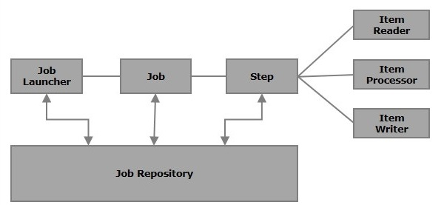

#### 1.Job

In a Spring Batch application, a job is the batch process that is to be executed. It runs from start to finish without interruption. This job is further divided into **steps** (or a job contains steps).

#### 2.Step

A step is an independent part of a job which contains the necessary information to define and execute the job (its part).

As specified in the diagram, each step is composed of an ItemReader, ItemProcessor (optional) and an ItemWriter. **A job may contain one or more steps**.

#### 3.Readers, Writers, and Processors

* ****Item reader**** reads data into a Spring Batch application from a particular source.
* ****Item writer**** writes data from the Spring Batch application to a particular destination.
* ****Item processor****is a class which contains the processing code which processes the data read into the spring batch. If the application reads **“n”** records, then the code in the processor will be executed on each record.

For example, if we are writing a job with a simple step in it where we read data from CSV , process it and write it to a Database then our step uses −

* A **reader** which reads from CSV file.
* A **writer** which writes to Database.
* A **custom processor** which processes the data as per our wish.

## Example

1.Update Maven Dependencies

*<!-- Batch -->*<**dependency**>  
 <**groupId**>org.springframework.boot</**groupId**>  
 <**artifactId**>spring-boot-starter-batch</**artifactId**>  
</**dependency**>  
<**dependency**>  
 <**groupId**>org.springframework.boot</**groupId**>  
 <**artifactId**>spring-boot-starter-quartz</**artifactId**>  
</**dependency**>

2.Configure Spring Batch properties in application.yaml

**spring**:  
 **batch**:  
 **jdbc**:  
 **initialize-schema**: ALWAYS *#To create spring_batch db tables* **job**:  
 **enabled**: false *#To prevent automatic execution of Job at Startup*

3.Spring Batch Configuration file.

This is main step in the batch processing. We will define SpringBatchConfig class with job details.

* Job
* ItemReader
* ItemProcessor
* ItemWriter

The Job method accepts following perameters. Here we will create Bean object for each parameter in separate method and pass it to Job. The parameters invoves here are

* **JobBuilderFactory** provides a convenient way to create and configure instances of the **Job** class.
* **StepBuilderFactory** provides methods to create and configure instances of the **Step** class.
* **ItemReader** is used to read data from a source.
* he **ItemProcessor** takes **UserDto** objects as input and processes them, possibly transforming them into **User** objects. The processed items are then passed to the writer.
* **ItemWriter** is responsible for taking the processed items (in this case, **User** objects) and writing them to a specified destination. This destination could be a database, a file, or any other type of output.

@Configuration  
@EnableBatchProcessing  
**public class** SpringBatchConfig {  
  
  
  
 @Bean  
 **public** Job job(JobBuilderFactory jobBuilderFactory,  
 StepBuilderFactory stepBuilderFactory,  
 ItemReader<UserDto> itemReader,  
 ItemProcessor<UserDto, User> itemProcessor,  
 ItemWriter<User> itemWriter  
 ) {  
  
 Step step = stepBuilderFactory.get(**"ETL-file-load"**)  
 .<UserDto, User>chunk(100)  
 .reader(itemReader)  
 .processor(itemProcessor)  
 .writer(itemWriter)  
 .build();  
  
  
 **return** jobBuilderFactory.get(**"ETL-Load"**)  
 .incrementer(**new** RunIdIncrementer())  
 .start(step)  
 .build();  
 }  
  
  
 @Bean  
 @StepScope  
 **public** FlatFileItemReader<UserDto> itemReader(@Value(**"#{jobParameters['inputFilePath']}"**) String inputFilePath) {  
 FlatFileItemReader<UserDto> flatFileItemReader = **new** FlatFileItemReader<>();  
 flatFileItemReader.setResource(**new** FileSystemResource(inputFilePath));  
 flatFileItemReader.setName(**"CSV-Reader"**);  
 flatFileItemReader.setLinesToSkip(1);  
 flatFileItemReader.setLineMapper(lineMapper());  
 **return** flatFileItemReader;  
 }  
  
  
 @Bean  
 **public** LineMapper<UserDto> lineMapper() {  
 *//DefaultLineMapper: is a class provided by the Spring Batch framework that is used for  
 // mapping lines of input data to domain objects.* DefaultLineMapper<UserDto> defaultLineMapper = **new** DefaultLineMapper<>();  
 DelimitedLineTokenizer lineTokenizer = **new** DelimitedLineTokenizer();  
  
 lineTokenizer.setDelimiter(**","**);  
 lineTokenizer.setStrict(**false**);  
 lineTokenizer.setNames(**"username"**, **"password"**);  
  
 *//BeanWrapperFieldSetMapper is used for mapping fields from a delimited or fixed-length file (typically a flat file)  
 // to a Java object.* BeanWrapperFieldSetMapper<UserDto> fieldSetMapper = **new** BeanWrapperFieldSetMapper<>();  
 fieldSetMapper.setTargetType(UserDto.**class**);  
  
 defaultLineMapper.setLineTokenizer(lineTokenizer);  
 defaultLineMapper.setFieldSetMapper(fieldSetMapper);  
  
 **return** defaultLineMapper;  
 }  
  
}

In above class we have defiend Job & ItemReader. Lets define ItemProcessor & ItemWriter in sperate classes.

@Component  
**public class** UserItemProcessor **implements** ItemProcessor<UserDto, User> {  
 @Override  
 **public** User process(UserDto userDto) **throws** Exception {  
 User user = **new** User();  
 user.setUsername(userDto.getUsername());  
 user.setPassword(userDto.getPassword());  
 **return** user;  
 }  
}

@Component  
**public class** UserItemWriter **implements** ItemWriter<User> {  
  
 **private** UserRepository **userRepository**;  
  
 @Autowired  
 **public** UserItemWriter(UserRepository userRepository) {  
 **this**.**userRepository** = userRepository;  
 }  
  
 @Override  
 **public void** write(List<? **extends** User> users) **throws** Exception{  
 System.***out***.println(**"Data Saved for Users: "** + users);  
 **userRepository**.saveAll(users);  
 }  
}

4. Other SpringBoot classes

//Controller

@PostMapping(**"/upload"**)  
**public** Object uploadFile(@RequestBody MultipartFile file, @RequestParam(**"isBatch"**) Boolean isBatch) {  
 **if** (file.isEmpty()) {  
 **throw new** BusinessException(**"File is Empty"**);  
 }  
  
 **return userService**.batchUploadUsers(file);

}

//Service

**public interface** UserService {  
  
  
 BatchStatus batchUploadUsers(MultipartFile file);  
}

@Service  
@Slf4j  
@AllArgsConstructor  
**public class** UserServiceImpl **implements** UserService {  
 @Autowired  
 **private** UserRepository **userRepository**;  
 @Autowired  
 **private** UserMapper **userMapper**;  
  
 @Autowired  
 **private** JobLauncher **jobLauncher**;  
  
 @Autowired  
 **private** Job **job**;  
  
  
 @Override  
 **public** BatchStatus batchUploadUsers(MultipartFile file) {  
 **try** {  
 *// Save the uploaded file to a temporary location* Path tempFile = Files.*createTempFile*(**"temp_users"**, **".csv"**);  
 file.transferTo(tempFile.toFile());  
  
 *// Set the file path in the job parameters* Map<String, JobParameter> maps = **new** HashMap<>();  
 maps.put(**"timestamp"**, **new** JobParameter(System.*currentTimeMillis*()));  
 maps.put(**"inputFilePath"**, **new** JobParameter(tempFile.toAbsolutePath().toString()));  
 JobParameters parameters = **new** JobParameters(maps);  
  
 *// Run the job with the updated parameters* JobExecution jobExecution = **jobLauncher**.run(**job**, parameters);  
  
 *// Clean up the temporary file (optional)* Files.*delete*(tempFile);  
  
 **return** jobExecution.getStatus();  
 } **catch** (Exception e) {  
 **throw new** RuntimeException(e);  
 }  
 }  
  
  
}

Run the Application & Check the API

# Spring Boot Reporting – Jasper Reports

Add maven Dependency.

*<!-- https://mvnrepository.com/artifact/net.sf.jasperreports/jasperreports -->*<**dependency**>  
 <**groupId**>net.sf.jasperreports</**groupId**>  
 <**artifactId**>jasperreports</**artifactId**>  
 <**version**>6.21.2</**version**>  
</**dependency**>

Controller

@RestController  
@RequestMapping(path = ApplicationConstants.***API_BASE*** + ApplicationConstants.***V1*** + **"reports"**)  
@Validated  
@Slf4j  
@RequiredArgsConstructor  
**public class** ReportsController {  
  
 @Autowired  
 **private final** ReportsService **reportsService**;  
   
 @GetMapping(**"/jasper/employee"**)  
 **public** ResponseEntity<Resource> employeeJasperReport(@RequestParam(**"fileType"**) String fileType) {  
 **try** {  
 String downloadFilePath = **reportsService**.employeeJasperReport(fileType);  
 Resource resource = **new** FileSystemResource(downloadFilePath);  
 HttpHeaders headers = **new** HttpHeaders();  
 headers.setContentType(MediaType.***APPLICATION_OCTET_STREAM***);  
 headers.setContentDispositionFormData(**"attachment"**, downloadFilePath);  
 **return** ResponseEntity.*ok*()  
 .headers(headers)  
 .body(resource);  
  
 } **catch** (Exception e) {  
 ***log***.error(e.getMessage(), e);  
 **throw new** BusinessException(**"Downloading Employees JSON Failed, Due to : "** + e.getMessage());  
 }  
 }  
}

EmployeeDto

**public class** EmployeeDto **implements** Serializable {  
  
 @XmlElement(required = **true**)  
 **private** Long **id**;  
  
 @XmlElement(required = **true**)  
 @NotNull  
 @Size(min = 4, max = 10)  
 **private** String **name**;  
  
 @XmlElement(name = **"salary"**, required = **true**)  
 @Digits(integer = 10, fraction = 2)  
 **private** Double **salary**;  
  
 @XmlElement  
 @Size(max = 20)  
 **private** String **city**;

}

Service

@Service  
@Slf4j  
@AllArgsConstructor  
**public class** ReportsServiceImpl **implements** ReportsService {  
  
 **private static final** String ***reportPath*** = **"download"**;  
  
 **private final** ObjectMapper **objectMapper**;  
 @Autowired  
 **private** EmployeeRepository **employeeRepository**;  
 @Autowired  
 **private** EmployeeMapper **employeeMapper**;  
  
 **public** List<EmployeeDto> getAllEmployees() {  
 List<Employee> employees = **employeeRepository**.findAll();  
 **return employeeMapper**.mapEntityListToDtoListForEmployee(employees);  
 }  
  
  
 @Override  
 **public** String employeeJasperReport(String fileType) {  
 String template = **"reports/emp.jrxml"**;  
 List<Employee> employees = **employeeRepository**.findAll();  
 List<EmployeeDto> employeeDtos = **employeeMapper**.mapEntityListToDtoListForEmployee(employees);  
 **return** generateJasperReport(template, employeeDtos, fileType);  
 }  
  
  
 **public** String generateJasperReport(String template, List dataSource, String fileType) {  
 **try** {  
 File file = ResourceUtils.*getFile*(**"classpath:"** + template);  
 InputStream input = **new** FileInputStream(file);  
  
 *// Compile the Jasper report from .jrxml to .japser* JasperReport jasperReport = JasperCompileManager.*compileReport*(input);  
  
 *// Get your data source* JRBeanCollectionDataSource source = **new** JRBeanCollectionDataSource(dataSource);  
 *// Add parameters* Map<String, Object> parameters = **new** HashMap<>();  
 parameters.put(**"createdBy"**, **"Satya Kaveti"**);  
 *// Fill the report* JasperPrint jasperPrint = JasperFillManager.*fillReport*(jasperReport, parameters, source);  
  
 String fileName = **"Employee_report_"** + LocalDateTime.*now*();  
 **return** exportJasperReport(jasperPrint, fileName, fileType);  
 } **catch** (Exception e) {  
 ***log***.error(**"Error Occurred"**, e);  
 **throw new** BusinessException(**"Error generateJasperReport"**);  
 }  
 }  
  
  
 **private** String exportJasperReport(JasperPrint jasperPrint, String fileName, String fileType) **throws** Exception {  
 String outputPath = **""**;  
 **switch** (fileType) {  
 **case "csv"**:  
 outputPath = ***reportPath*** + **"//"** + fileName + **".csv"**;  
 JRCsvExporter csvExporter = **new** JRCsvExporter();  
 csvExporter.setExporterInput(**new** SimpleExporterInput(jasperPrint));  
 csvExporter.setExporterOutput(**new** SimpleWriterExporterOutput(outputPath));  
 SimpleCsvExporterConfiguration csvConfiguration = **new** SimpleCsvExporterConfiguration();  
 csvConfiguration.setFieldDelimiter(**","**);  
 csvExporter.setConfiguration(csvConfiguration);  
 csvExporter.exportReport();  
 **break**;  
 **case "xlsx"**:  
 outputPath = ***reportPath*** + **"//"** + fileName + **".xlsx"**;  
 JRXlsxExporter xlsxExporter = **new** JRXlsxExporter();  
 xlsxExporter.setExporterInput(**new** SimpleExporterInput(jasperPrint));  
 xlsxExporter.setExporterOutput(**new** SimpleOutputStreamExporterOutput(outputPath));  
 SimpleXlsxReportConfiguration xlsxConfiguration = **new** SimpleXlsxReportConfiguration();  
 xlsxConfiguration.setOnePagePerSheet(**true**);  
 xlsxConfiguration.setRemoveEmptySpaceBetweenColumns(**true**);  
 xlsxConfiguration.setDetectCellType(**true**);  
 xlsxExporter.setConfiguration(xlsxConfiguration);  
 xlsxExporter.exportReport();  
 **break**;  
 **case "html"**:  
 outputPath = ***reportPath*** + **"//"** + fileName + **".html"**;  
 JasperExportManager.*exportReportToHtmlFile*(jasperPrint, outputPath);  
 **break**;  
 **case "xml"**:  
 outputPath = ***reportPath*** + **"//"** + fileName + **".xml"**;  
 JasperExportManager.*exportReportToXmlFile*(jasperPrint, outputPath, **true**);  
 **break**;  
 **default**:  
 outputPath = ***reportPath*** + **"//"** + fileName + **".pdf"**;  
 JasperExportManager.*exportReportToPdfFile*(jasperPrint, outputPath);  
 }  
  
 ***log***.info(fileType.toUpperCase() + **" File Generated at "** + outputPath);  
 **return** outputPath;  
 }  
}

Emp.jrxml

*<?***xml version="1.0" encoding="UTF-8"***?>  
<!-- Created with Jaspersoft Studio version 6.20.3.final using JasperReports Library version 6.20.3-415f9428cffdb6805c6f85bbb29ebaf18813a2ab -->*<**jasperReport xmlns="http://jasperreports.sourceforge.net/jasperreports" xmlns:xsi="http://www.w3.org/2001/XMLSchema-instance" xsi:schemaLocation="http://jasperreports.sourceforge.net/jasperreports http://jasperreports.sourceforge.net/xsd/jasperreport.xsd" name="employee-rpt" pageWidth="595" pageHeight="842" columnWidth="555" leftMargin="20" rightMargin="20" topMargin="20" bottomMargin="20" uuid="c51ad21b-aa1c-447f-bd4e-8377618fcdfb"**>  
 <**property name="ireport.zoom" value="1.0"**/>  
 <**property name="ireport.x" value="0"**/>  
 <**property name="ireport.y" value="0"**/>  
 <**parameter name="createdBy" class="java.lang.String"**/>  
 <**field name="id" class="java.lang.Long"**/>  
 <**field name="name" class="java.lang.String"**/>  
 <**field name="city" class="java.lang.String"**/>  
 <**field name="salary" class="java.lang.Double"**/>  
 <**background**>  
 <**band height="20" splitType="Stretch"**/>  
 </**background**>  
 <**title**>  
 <**band height="63" splitType="Stretch"**>  
 <**staticText**>  
 <**reportElement x="0" y="6" width="560" height="50" forecolor="#0777EC" uuid="72542b4a-93ee-4591-a8ad-f11274f6eb52"**/>  
 <**textElement textAlignment="Center" verticalAlignment="Middle"**>  
 <**font size="37" isBold="true"**/>  
 </**textElement**>  
 <**text**><![CDATA[Employee Details]]></**text**>  
 </**staticText**>  
 </**band**>  
 </**title**>  
 <**columnHeader**>  
 <**band height="61" splitType="Stretch"**>  
 <**staticText**>  
 <**reportElement x="0" y="41" width="111" height="20" uuid="a5237c32-d009-489d-b664-69fdad2bb1cd"**/>  
 <**box**>  
 <**pen lineWidth="0.25"**/>  
 <**topPen lineWidth="0.25"**/>  
 <**leftPen lineWidth="0.25"**/>  
 <**bottomPen lineWidth="0.25"**/>  
 <**rightPen lineWidth="0.25"**/>  
 </**box**>  
 <**textElement textAlignment="Center"**>  
 <**font size="12" isBold="true" isItalic="false"**/>  
 </**textElement**>  
 <**text**><![CDATA[ID]]></**text**>  
 </**staticText**>  
 <**staticText**>  
 <**reportElement x="111" y="41" width="209" height="20" uuid="9f53e136-c945-41c7-9e37-2ff363df5e7d"**/>  
 <**box**>  
 <**pen lineWidth="0.25"**/>  
 <**topPen lineWidth="0.25"**/>  
 <**leftPen lineWidth="0.25"**/>  
 <**bottomPen lineWidth="0.25"**/>  
 <**rightPen lineWidth="0.25"**/>  
 </**box**>  
 <**textElement textAlignment="Center"**>  
 <**font size="12" isBold="true" isItalic="false"**/>  
 </**textElement**>  
 <**text**><![CDATA[Name]]></**text**>  
 </**staticText**>  
 <**staticText**>  
 <**reportElement x="432" y="40" width="111" height="20" uuid="4f8a1baf-6650-4dc7-bf50-72fd30c9ea73"**/>  
 <**box**>  
 <**pen lineWidth="0.25"**/>  
 <**topPen lineWidth="0.25"**/>  
 <**leftPen lineWidth="0.25"**/>  
 <**bottomPen lineWidth="0.25"**/>  
 <**rightPen lineWidth="0.25"**/>  
 </**box**>  
 <**textElement textAlignment="Center"**>  
 <**font size="12" isBold="true" isItalic="false"**/>  
 </**textElement**>  
 <**text**><![CDATA[City]]></**text**>  
 </**staticText**>  
 <**staticText**>  
 <**reportElement x="320" y="40" width="111" height="20" uuid="618033d2-a415-4315-8f4b-d5e67727ee58"**/>  
 <**box**>  
 <**pen lineWidth="0.25"**/>  
 <**topPen lineWidth="0.25"**/>  
 <**leftPen lineWidth="0.25"**/>  
 <**bottomPen lineWidth="0.25"**/>  
 <**rightPen lineWidth="0.25"**/>  
 </**box**>  
 <**textElement textAlignment="Center"**>  
 <**font size="12" isBold="true" isItalic="false"**/>  
 </**textElement**>  
 <**text**><![CDATA[Salary]]></**text**>  
 </**staticText**>  
 </**band**>  
 </**columnHeader**>  
 <**detail**>  
 <**band height="20" splitType="Stretch"**>  
 <**textField**>  
 <**reportElement x="0" y="0" width="111" height="20" uuid="fd09b48e-3bab-436c-8f5b-08f868b0ada0"**/>  
 <**box**>  
 <**pen lineWidth="0.25"**/>  
 <**topPen lineWidth="0.25"**/>  
 <**leftPen lineWidth="0.25"**/>  
 <**bottomPen lineWidth="0.25"**/>  
 <**rightPen lineWidth="0.25"**/>  
 </**box**>  
 <**textElement textAlignment="Center"**/>  
 <**textFieldExpression**><![CDATA[$F{id}]]></**textFieldExpression**>  
 </**textField**>  
 <**textField**>  
 <**reportElement x="111" y="0" width="209" height="20" uuid="40e29be5-cdd9-409a-a658-8170b7f48335"**/>  
 <**box**>  
 <**pen lineWidth="0.25"**/>  
 <**topPen lineWidth="0.25"**/>  
 <**leftPen lineWidth="0.25"**/>  
 <**bottomPen lineWidth="0.25"**/>  
 <**rightPen lineWidth="0.25"**/>  
 </**box**>  
 <**textElement textAlignment="Center"**/>  
 <**textFieldExpression**><![CDATA[$F{name}]]></**textFieldExpression**>  
 </**textField**>  
 <**textField**>  
 <**reportElement x="431" y="0" width="112" height="20" uuid="4d6f4263-82f4-4941-b213-a9b3a38e8a61"**/>  
 <**box**>  
 <**pen lineWidth="0.25"**/>  
 <**topPen lineWidth="0.25"**/>  
 <**leftPen lineWidth="0.25"**/>  
 <**bottomPen lineWidth="0.25"**/>  
 <**rightPen lineWidth="0.25"**/>  
 </**box**>  
 <**textElement textAlignment="Center"**/>  
 <**textFieldExpression**><![CDATA[$F{city}]]></**textFieldExpression**>  
 </**textField**>  
 <**textField**>  
 <**reportElement x="320" y="0" width="111" height="20" uuid="f05cbafb-5573-4949-af01-4a77d5663b55"**/>  
 <**box**>  
 <**pen lineWidth="0.25"**/>  
 <**topPen lineWidth="0.25"**/>  
 <**leftPen lineWidth="0.25"**/>  
 <**bottomPen lineWidth="0.25"**/>  
 <**rightPen lineWidth="0.25"**/>  
 </**box**>  
 <**textElement textAlignment="Center"**/>  
 <**textFieldExpression**><![CDATA[$F{salary}]]></**textFieldExpression**>  
 </**textField**>  
 </**band**>  
 </**detail**>  
 <**pageFooter**>  
 <**band height="46"**>  
 <**textField pattern="dd-MMMM-yyy, hh:mm a"**>  
 <**reportElement x="390" y="10" width="159" height="20" uuid="f1bb769a-fb80-4e73-b8af-e51c51ce6796"**/>  
 <**textElement textAlignment="Right" verticalAlignment="Middle"**/>  
 <**textFieldExpression**><![CDATA[new java.util.Date()]]></**textFieldExpression**>  
 </**textField**>  
 <**staticText**>  
 <**reportElement x="230" y="10" width="58" height="20" uuid="f83a30eb-da24-4666-a1c3-767e232a3d95"**/>  
 <**textElement textAlignment="Center" verticalAlignment="Middle"**/>  
 <**text**><![CDATA[Created By:]]></**text**>  
 </**staticText**>  
 <**textField**>  
 <**reportElement x="288" y="10" width="99" height="20" uuid="00dc7055-16ed-4472-80dd-342ff337dfcf"**/>  
 <**textElement textAlignment="Left" verticalAlignment="Middle"**/>  
 <**textFieldExpression**><![CDATA[$P{createdBy}]]></**textFieldExpression**>  
 </**textField**>  
 </**band**>  
 </**pageFooter**>  
</**jasperReport**>

# Spring Boot Reporting – Corbone Reports

Carbone Won’t support Java.

We have used in NodeJs Project.

## Example with Cloud

Requirements

* Create a Carbone Cloud account or sign-in: <https://account.carbone.io/>
* For **testing** purposes, use a test API key: Generate unlimited watermarked PDFs for free (Only PDF file format).
* For **production** purposes, use a production API key: Generate any document formats without a watermark. The free **Sandbox Plan** plan is available, giving you 100 credits per month. If you need more credits, you can upgrade your subscription.

Quickstart & API Flow

To generate a document, you have to:

* Upload a template to get a **template ID**. The template is stored in your personal template storage.
* Generate a report from the **template ID** and a **JSON dataset**, then the request returns a unique usable **render ID**.
* Download the report thanks to the **render ID**.
* To get a new document, repeat the process from point 2.

Test the API with [Carbone Cloud API quickstart](https://carbone.io/documentation.html#quickstart-carbone-cloud-api)

API Calls

TEMPLATE_ID

5d7077481690ec0c0c63cfc04472ccc9c2afd635ae66500eb0313571ec2ff022

Bearer API_KEY

test_eyJhbGciOiJFUzUxMiIsInR5cCI6IkpXVCJ9.eyJpc3MiOiI1MzE1MjUwOTE1NjI2ODY1ODUiLCJhdWQiOiJjYXJib25lIiwiZXhwIjoyMzM1MDc3OTI5LCJkYXRhIjp7ImlkQWNjb3VudCI6IjUzMTUyNTA5MTU2MjY4NjU4NSJ9fQ.AN7CtEIaJA5FUR2qkcsAs7YvABs1OMxSqC56OgdJWsz4TfYlpwm5Ow0bMz1g8DW6PX0QDLXd3onmJfg_PLQ2LU9YAV5y3bH-8fgGU-3n1jq6mWB8wm2Fp7H3ajiidfqXxZnZzw7FhqRAYlMboTArqx0S6x8-myUU5uceQfOg8PRaa4Bv

Get a template with CURL

curl --location --request GET 'https://api.carbone.io/template/5d7077481690ec0c0c63cfc04472ccc9c2afd635ae66500eb0313571ec2ff022' \

--header 'carbone-version: 4' \

--header 'Authorization: test_eyJhbGciOiJFUzUxMiIsInR5cCI6IkpXVCJ9.eyJpc3MiOiI1MzE1MjUwOTE1NjI2ODY1ODUiLCJhdWQiOiJjYXJib25lIiwiZXhwIjoyMzM1MDc3OTI5LCJkYXRhIjp7ImlkQWNjb3VudCI6IjUzMTUyNTA5MTU2MjY4NjU4NSJ9fQ.AN7CtEIaJA5FUR2qkcsAs7YvABs1OMxSqC56OgdJWsz4TfYlpwm5Ow0bMz1g8DW6PX0QDLXd3onmJfg_PLQ2LU9YAV5y3bH-8fgGU-3n1jq6mWB8wm2Fp7H3ajiidfqXxZnZzw7FhqRAYlMboTArqx0S6x8-myUU5uceQfOg8PRaa4Bv' \

-o 'FILENAME.docx'

Render a report with Curl

curl --location --request POST 'https://api.carbone.io/render/5d7077481690ec0c0c63cfc04472ccc9c2afd635ae66500eb0313571ec2ff022' \

--header 'carbone-version: 4' \

--header 'Content-Type: application/json' \

--header 'Authorization: test_eyJhbGciOiJFUzUxMiIsInR5cCI6IkpXVCJ9.eyJpc3MiOiI1MzE1MjUwOTE1NjI2ODY1ODUiLCJhdWQiOiJjYXJib25lIiwiZXhwIjoyMzM1MDc3OTI5LCJkYXRhIjp7ImlkQWNjb3VudCI6IjUzMTUyNTA5MTU2MjY4NjU4NSJ9fQ.AN7CtEIaJA5FUR2qkcsAs7YvABs1OMxSqC56OgdJWsz4TfYlpwm5Ow0bMz1g8DW6PX0QDLXd3onmJfg_PLQ2LU9YAV5y3bH-8fgGU-3n1jq6mWB8wm2Fp7H3ajiidfqXxZnZzw7FhqRAYlMboTArqx0S6x8-myUU5uceQfOg8PRaa4Bv' \

--data-raw '{

"data": [

{

"id": 3,

"name": "Satya",

"salary": 25000.0,

"city": "HYD",

"account": {

"id": 3,

"email": "satya@gmail.com",

"password": "password",

"dob": "1990-10-27"

},

"documentList": [

{

"id": 3,

"proofType": "VOTERID",

"docName": "VoterID",

"docUrl": "voterIDURL"

}

],

"createdBy": null,

"modifiedBy": null,

"createdDate": "2023-10-27T10:59:54.891+00:00",

"modifiedDate": "2023-10-27T10:59:54.891+00:00"

},

{

"id": 4,

"name": "Satya 2",

"salary": 25000.0,

"city": "HYD",

"account": {

"id": 4,

"email": "satya@gmail.com",

"password": "password",

"dob": "1990-10-27"

},

"documentList": [

{

"id": 4,

"proofType": "VOTERID",

"docName": "VoterID",

"docUrl": "voterIDURL"

}

],

"createdBy": null,

"modifiedBy": null,

"createdDate": "2023-10-27T11:00:00.231+00:00",

"modifiedDate": "2023-10-27T11:00:30.571+00:00"

}

],

"convertTo": "pdf"

}'

{"success":true,"data":{"renderId":"MTAuMjAuMTEuNDEgICAgRRWtcLz8wl-1sP4EhNVJ5gcmVwb3J0.pdf"}}**%**

Ref:

<https://carbone.io/api-reference.html>

<https://studio.carbone.io/#/studio>